KammavariSangham(R)1952,K.S.GroupofInstitutions
K.S.SCHOOLOFENGINEERING&MANAGEMENT
No.15,Mallasandra,Off.KanakapuraRoad,Bengaluru-560109
AffiliatedtoVTU,Belagavi&ApprovedbyAICTE,NewDelhi,AccreditedbyNAAC
FacultyName | JAYASHREE G R | Photo  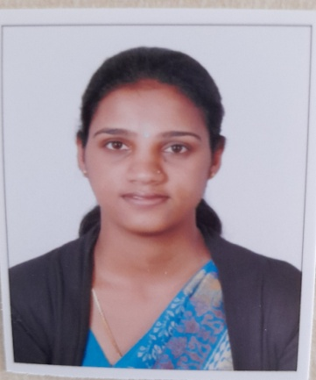
Designation | Assistant Professor
EducationalQualification | M.Tech(Signal Processing)  BE(ECE)
ExperienceinYears | Teaching: 3 years  Industry: 0
Areas of Interest | Signal processing, Biomedical signal processing, Image processing
Subjects Taught | Microwave and antennas  Digital communication  Microcontrollers  Satellite communication  Field theory  DSP lab  CCN Lab  Communication lab
E-mail ID | jayashree@kssem.edu.in
EDUCATIONALDETAILS:-
Examination/Degree | College/University | Year of Passing
BE | Jain university | 2015
M.Tech | SJCIT/ VTU | 2017
PH.D
Journal Publications:
- Jayashree G R, Dr K M Ravi Kumar, Ravi kiran, “Renal cell Carcinoma Nuclear Grading using 2D textural features for kidney images”, International Journal of advance research ideas and innovations in Technology, Volume-3, Issue-3- May-June, 2017.

CONTACTDETAILS:-
Name: JAYASHREE G R
Officialaddress:No.15,Mallasandra,Off.KanakapuraRoad,Bengaluru-560109
Personal Mail id: jayashree27.93@gmail.com
Contact Number: 9036185089

