Kammavari Sangham (R) 1952, K. S. Group of Institutions
K. S. SCHOOL OF ENGINEERING & MANAGEMENT
No.15, Mallasandra, Off. Kanakapura Road, Bengaluru-560109
Affiliated to VTU, Belagavi & Approved by AICTE, New Delhi, Accredited by NAAC
Faculty Name | Mr. Sanjay B. Nayak | 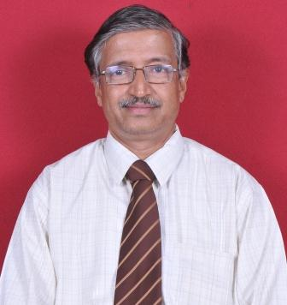
Designation | Faculty
Educational Qualification | M.E
Experience in Years | Teaching: 20 Yrs  Industry: 16 Yrs
Areas of Interest | Control Systems, Computer Programming
Subjects Taught | C++ Programming, Control Systems, Management
E-mail ID | Sanjay.baburao.nayak@kssem.edu.in
EDUCATIONAL DETAILS:-
Examination / Degree | College/University | Year of Passing
BE | GEC/Bombay University | 1983
M. Tech | Walchand College/ Shivaji University | 1988
PH.D

Professional Membership
- MISTE
- FIE

CONTACT DETAILS:-
Name: Mr. Sanjay B. Nayak
Official address: No.15, Mallasandra, Off. Kanakapura Road, Bengaluru-560109 Personal Mail id: sbn2509@gmail.com
Contact Number: 9902422600

