Kammavari Sangham (R) 1952, K. S. Group of Institutions
K. S. SCHOOL OF ENGINEERING & MANAGEMENT
No.15, Mallasandra, Off. Kanakapura Road, Bengaluru-560109
Affiliated to VTU, Belagavi & Approved by AICTE, New Delhi, Accredited by NAAC
Faculty Name | Mrs. Deepa R Bhangi | 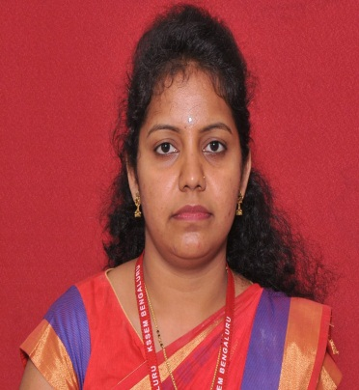
Designation | Assistant Professor
Educational Qualification | M.Tech.,(Ph.D)
Experience in Years | Teaching:6.4 Yrs  Industry: -
Areas of Interest | VLSI Design and Embedded Systems
Subjects Taught | Basic Electronics, Digital System Design using Verilog, VLSI Design, Electronic Devices And Instrumentation,operational research, Electronic magnetics and Field Theory, Network Theory, FEEE, EM, IT Skills.
E-mail ID | deepa.bhangi@kssem.edu.in
EDUCATIONAL DETAILS:-
Examination / Degree | College/University | Year of Passing
BE | SJMIT, Chitradurga | 2011
M. Tech | VTU, Belagavi | 2013
PH.D | SDMCET, Dharwad | -
PUBLICATIONS:-
ORCID ID:

Journal Publications:

Conference Papers:

Professional Membership

CONTACT DETAILS:-
Name: Deepa R Bhangi
Official address: No.15, Mallasandra, Off. Kanakapura Road, Bengaluru-560109 Personal Mail id: bangi.deepu73@gmail.com
Contact Number:9844446033

